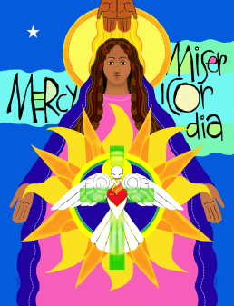

Office of Catechesis
2016-2017 Calendar

July 10-14 | Parish Catechetical Leadership Institute at St. Meinrad
August 18 | Parish Catechetical Leader meeting, 9AM- 2PM (CST) at the Catholic Center
August 26 | Evening of Reflection with ValLimar Jansen, 6:30PM- 8:30PM (CST) at St. Benedict Cathedral
August 27 | 6th Annual Catechist Formation Day: Proclaiming Jesus’ Message of Mercy and Hope, 8AM- 2PM (CST) at the Catholic Center
September 15 | Parish Catechetical Leaders meeting, 8:30AM- 1:30PM (CST) at the Catholic Center
September 18 | Catechetical Sunday
September 23-25 | Vatican Jubilee for Catechists
October 7-9 | Women of the Church Conference at Monastery Immaculate Conception
October 20 | Parish Catechetical Leaders meeting, 8:30AM- 1:30PM (CST) at the Catholic Center
October 30 | Brute Awards Mass with Bishop Thompson, 1:30PM (CST) at St. Benedict Cathedral
November 6-12 | National Vocations Awareness Week
November 10-11 | Catholic Leadership Reflection Days at French Lick Resort
November 17 | Parish Catechetical Leaders meeting, 8:30AM- 1:30PM (CST) at the Catholic Center
November 24- 25 | Happy Thanksgiving! Catholic Center Closed
December 1-3 | National Conference on Catholic Youth Ministry, San Jose, CA
December 15 | Parish Catechetical Leaders meeting, 8:30AM- 1:30PM (CST) at the Catholic Center
December 24- January 2 | Merry Christmas! Catholic Center Closed
January 19 | DAPCA/ Parish Catechetical Leaders Retreat, 8:30AM-1:30PM (CST)
January 25-29 | Pilgrimage for Life
January 21 | RCIA Retreat, 8:30- 11:30AM (CST) at the Catholic Center. Opening Prayer with Bishop Thompson
January 29- February 4 | Catholic Schools Week
February 4 | Confirmation Spectacular, 12:30- 5:30 (EST) at St. Joseph Church in Jasper, IN. Mass with Bishop Thompson at 4PM (EST)
February 16 | Parish Catechetical Leaders meeting, 8:30AM- 1:30PM (CST) at the Catholic Center
March 5 | Rite of Election, 2PM (CST) at St. Benedict Cathedral
March 16 | Parish Catechetical Leaders meeting, 8:30AM- 1:30PM (CST) at the Catholic Center
April 14 | Good Friday- Catholic Center Closed
April 16 | Happy Easter!
April 27 | Parish Catechetical Leaders meeting, 8:30AM- 1:30PM (CST) at the Catholic Center
May 18 | Mass with Bishop Thompson & Parish Catechetical Leaders meeting, 8:30AM- 1:30PM (CST) at the Catholic Center
May 22-25 | NCCL Conference in Dallas

