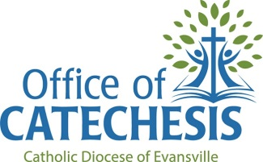
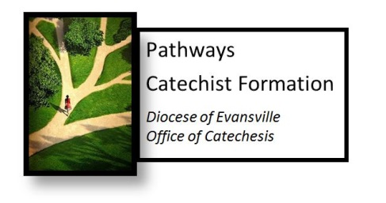

Pathways Checklist for Catholic School Teachers

Step 1: For all Catholic School Teachers
Completed 4 sessions: Trinity Date completed _________ Sacraments Date completed _________
Morality Date completed _________ Prayer Date completed _________

Step 2: For teachers with less than 5 years of experience teaching religion.
  - Completed Catechetical Methods & Skills Parts 1 & 2 or
  - Completed VLCFF Courses Basic Catechist Formation: Seminars 1.1 & 1.2 & Catholic Beliefs
    - Date completed __________________________________

Step 3: For Catholic School Religion Teachers who do not have a master’s degree in theology or a related field
Completed the following courses:
  - Introduction to Scripture (local) or VLCFF’s Bible Basics (online)
    - Date completed __________________________________
  - Sacraments (local) or online course
    - Date completed __________________________________
  - Old Testament (local) or online course
    - Date completed __________________________________
  - Morality (local) or online course
    - Date completed __________________________________
  - Prayer (local) or online course
    - Date completed __________________________________
  - New Testament (local) or online course
    - Date completed __________________________________
  - Catholic Social Teaching (local) or online course
    - Date completed __________________________________
  - Christology (local) or online course
    - Date completed __________________________________
  - Ecclesiology (local) or online course
    - Date completed __________________________________

Step 4: For those who have completed Steps 1-3 or who have a master’s degree in theology or a related field.
Create a yearly individual formation plan using the provided guide.

In addition, teachers are asked to participate in a Spiritual Formation component each year. Examples of this are attending a retreat, spiritual direction, participating in a small group, etc. Those can be listed below.
Year | Spiritual Formation Component
Questions? Contact the Office of Catechesis at 812-424-5536 ext. 228 or email agunter@evdio.org.

