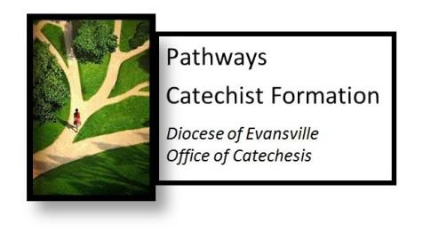

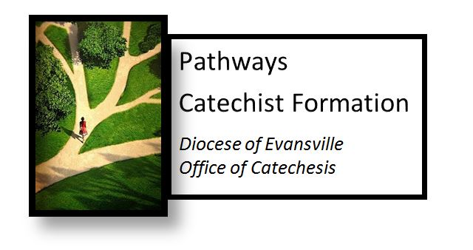

* Catechists who have completed steps 1-3 or who have a master’s degree in Theology or a related field will develop a personal yearly plan for formation for theological and catechetical growth
* In addition, catechists are asked to participate in a spiritual formation opportunity yearly.

Step

4

Step

3

* A comprehensive study of core theological concepts.
* Courses will be offered on a rotating basis. Each course is 6-10 hours. Two courses will be introduced each year.
* Catechists take one course per year. They can be taken in any order except for Introduction to Scripture. This course must be taken before other Scripture courses.
* The cost is 20.00 per course. Parishes and schools will be billed. No bill will exceed $200.00 per year.
* Online courses through the University of Dayton are an alternative option. Please contact the Office of Catechesis for more information.
* In addition, catechists are asked to participate in a spiritual formation opportunity yearly.

Step

2

* Introduces catechists to methodology and skills for presenting faith formation concepts in light of the Diocese of Evansville curriculum: *Forming a People of Faith.*
* Participant options:
  + 2 Semesters of either: Five 2 ½ hour sessions or 2 consecutive Saturdays. Semesters do not have to be done back to back.
  + 5 week online course Introduction to Catechesis through Dayton University
* $20 per semester, billed to the parish or school
* In addition, catechists are asked to participate in a spiritual formation opportunity yearly.

Step

1

* 4 one-hour sessions on the Trinity, Sacraments, Morality and Prayer. Provides a foundation of knowledge and experience focused on basic Catholic teaching.
* Offered every year for new catechists/ new Catholic school teachers by the Office of Catechesis.
* In addition, catechists/ Catholic school teachers are asked to participate in a spiritual formation opportunity yearly.