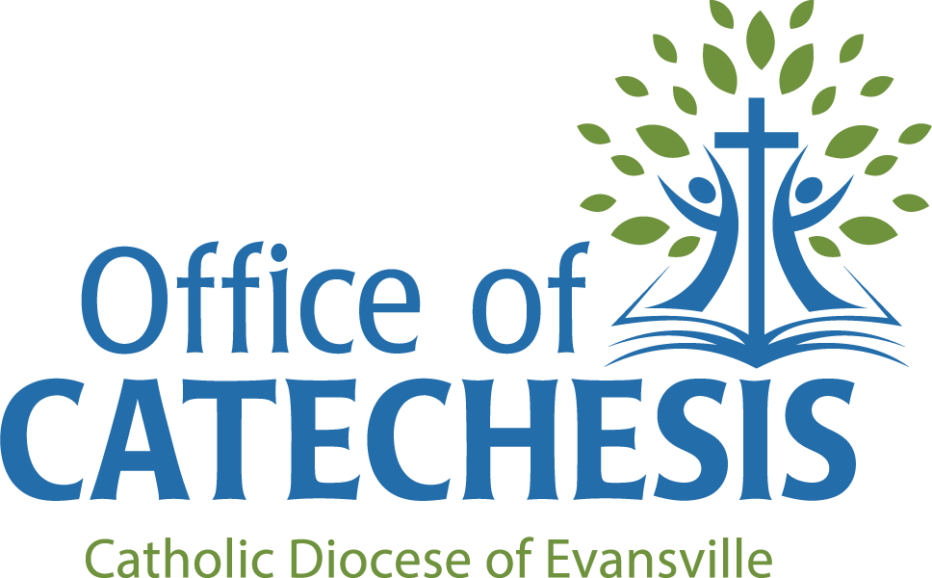

Preferred resources/Programs for Parish Religious Education and Sacramental Preparation

Index
1. For Religious Education Programs based on Grade Level
2. For Religious Education Programs based on Family-Centered Catechesis
3. For First Reconciliation Preparation
A. Stand-Alone Programs
B. Textbooks that Include First Communion Preparation
C. Supplements
4. For First Communion Preparation
A. Stand-Alone Programs
B. Textbooks that Include First Communion Preparation
5. For Confirmation Preparation
6. For Theology of the Body
7. For OCIA/RCIA

1. For Religious Education Programs based on Grade Level

“Word of Life” (Parish Edition)
Publisher: Augustine Institute & Ignatius Press: wordoflifeseries.org/school-parish
Description: Word of Life is designed to provide effective tools to both catechize and evangelize students and families. The materials engage students at all ages and experience levels, and the Parish Catechist Manuals are written for catechists of all levels of formation.

“Spirit of Truth” (Parish Edition)
Publisher: Sophia Institute: sophiateachers.org/promo/spirit-of-truth-k-8-parish-edition/
Structure: Follows a theme over the course of each year; 33 sessions
Description: Great resource for well-formed Catechists who want a deep and wide tool belt of material to choose from to teach. This heavily scripture-based K-8 curriculum will help you take your students on a deep and lasting journey through the Catholic Faith over 33 weekly sessions, but the schedule can be modified to even accommodate an 18-week program. Spirit of Truth provides you with a full year of varied and engaging lessons, helping you create a learning environment that captures students’ imaginations while improving knowledge retention.

“Walking with Jesus”
Publisher: Sophia Institute: sophiateachers.org/promo/walkingwithjesus/
Structure: Follows the liturgical calendar and based on the readings at mass
Description: Each grade level consists of 24 sessions to be presented within a 45-60 minute class. This curriculum doesn’t spend as much time going through the connections between the different parts of the faith and is much more beginner-friendly for Catechists who still want the valuable wealth of material that Sophia Institute has come to be known for.

2. For Religious Education Programs based on Family-Centered Catechesis

“Family of Faith”/“Una Familia de Fe”
Publisher: Sophia Institute: sophiateachers.org/promo/a-family-of-faith/
Description: English and Spanish editions available. Whole Family Catechesis, Monthly formation staggered by monthly activities of liturgy, fellowship, and activities (meets every other week on a 4-year cycle). The parents are expected to teach their children two lessons over the course of the month between formation meetings. (Monthly Formation → Parent Lesson at Home → Monthly Activity → Parent Lesson at Home → Repeat).

3. For First Reconciliation Preparation

A. Stand-Alone Programs

“Renewed: Your Journey to First Reconciliation”
Publisher: Ascension: ascensionpress.com/collections/renewed-your-journey-to-first-reconciliation
Description: Renewed: Your Journey to First Reconciliation is a twelve-lesson program that provides everything you need to prepare children to receive the Sacrament of Reconciliation. It features live-action videos with stunning animations that help communicate the spiritual dimension of the faith to children in a way they can easily understand. The program offers a Student Workbook, a Leader’s Guide, Online Parent Certification, a take-with-you Reconciliation book, family activity crates, and more.

“Signs of Grace: You Are Forgiven”
Publisher: Augustine Institute: thesignsofgrace.org/you-are-forgiven/
Description: 7 sessions. Signs of Grace: You Are Forgiven prepares children to receive the Sacrament of Reconciliation for the first time by revealing that God is indeed “rich in mercy.” Parent sessions, using Augustine Institute Studio’s Forgiven: The Transforming Power of Confession, help meet the crucial need for ongoing formation and catechesis for the entire family.

B. Textbooks that Include First Reconciliation Preparation

“Word of Life” (2nd Grade – Parish Edition)
Publisher: Augustine Institute & Ignatius Press: wordoflifeseries.org
Description: The 2nd-grade parish edition of the Word of Life series offers a comprehensive and holistic approach to catechesis and sacramental preparation.

“Spirit of Truth – Our Life in Jesus” (2nd Grade – Parish Edition)
Publisher: Sophia Institute: sophiateachers.org/promo/spirit-of-truth-k-8-parish-edition/
Description: 2nd-grade parish edition of the Spirit of Truth series designed to facilitate Religious Education in general, as well as preparation for the reception of the sacraments of First Reconciliation and First Communion.

C. Supplements

“My Reconciliation Book”/“Mi Libro de la Reconciliación”
Publisher: Our Sunday Visitor: orderosv.com/product/encounter-with-christ-my-reconciliation-book
Description: English and Spanish editions available.

4. For First Communion Preparation

A. Stand-Alone Programs

“Signs of Grace: You Are Loved
Publisher: Augustine Institute: thesignsofgrace.org/your-are-loved/
Description: Engaging, well-known presenters (Chris Stefanick, Matt Fradd, etc.). Each session includes a short video that is carefully crafted to ease the child into the lesson for the day, helping them become open and excited for what they will learn. Animation, hand-drawn Catholic symbols and graphics, engaging sound, and warm, entertaining presenters meet them at their level and convey the big idea of what is about to be unpacked by their teacher. Includes Presence for adults.

“Received: Your Journey to First Communion”
Publisher: Ascension: ascensionpress.com/collections/received-your-journey-to-first-communion
Description: Received: Your Journey to First Communion is a twelve-lesson program that provides everything you need to prepare children to receive the Sacrament of the Eucharist. It features live-action videos with stunning animations that help communicate the spiritual dimension of the Faith to children in a way they can easily understand. The program also offers a Student Workbook, a Leader’s Guide, an Online Parent Certification, a take-with-you Mass book, family activity crates, and more.

“The Mass: Unit Study”
Publisher: Into the Deep: intothedeep.co/collections/unit-studies/products/the-mass-unit-study
Description: A Scripture-heavy catechesis that teaches about the Mass in the full scope of Salvation History. This unit study can be used in whole-family catechesis, during the morning time, or during family devotional time. Ideal ages are 7-15.

B. Textbooks that Include First Communion Preparation

“Word of Life” (2nd Grade – Parish Edition)
Publisher: Augustine Institute & Ignatius Press: wordoflifeseries.org
Description: The 2nd-grade parish edition of the Word of Life series offers a comprehensive and holistic approach to catechesis and sacramental preparation.

“Spirit of Truth – Our Life in Jesus” (2nd Grade – Parish Edition)
Publisher: Sophia Institute: sophiateachers.org/promo/spirit-of-truth-k-8-parish-edition/
Description: 2nd-grade parish edition of the Spirit of Truth series designed to facilitate religious education in general, as well as preparation for the reception of the sacraments of First Reconciliation and First Communion.

5. For Confirmation Preparation

“Sealed in Fire”
Publisher: Sophia Institute for Teachers: sophiateachers.org/promo/sacramental-prep/
Description: For Grades 5-8 (there is also a version for 8-9 year olds: Sealed in Fire – Restored Order). There are 7 lessons included in a teacher’s guide provides dozens of teacher-written, classroom-tested activities that prepare students to receive an outpouring of the Holy Spirit in the Sacrament of Confirmation. The veteran schoolteachers who wrote the lessons included here know firsthand the needs of a classroom. These lessons are “substitute proof” and are designed in a flexible, modular format.

“Purpose”
Publisher: LifeTeen: purposeconfirmation.com
Description: Purpose is a transformative approach to confirmation. Multiple components combine an impactful curriculum with a powerful digital tool to enhance communication and ease administrative tasks. The Purpose curriculum is 24 sessions with a heavy focus on evangelizing young people and accompanying them as they become disciples. There are four versions of the 24-session curriculum, each adapted for a specific group.

“Chosen: Your Journey to Confirmation”
Publisher: Ascension Press: ascensionpress.com/collections/chosen-your-journey-to-confirmation
Description: For Grades 7-11. Filmed in over fifty locations in the United States and around the world, Chosen features fourteen of the top youth experts in the Church today. Chosen was created with teens and with the catechists in mind. The authors of Chosen, who are teachers themselves, have mapped out comprehensive and flexible lessons.

“Signs of Grace: You Are Sent”
Publisher: Augustine Institute: thesignsofgrace.org/you-are-sent/
Description: Approx. ages 7-9. Over 5 sessions, it prepares children to receive the Sacrament of Confirmation by helping them discover more deeply the presence and power of the Holy Spirit that they will receive in order to be sent on mission to be witnesses of Jesus. Parent sessions presented by Dr. Brant Pitre will help the entire family learn about the powerful and life-changing Sacrament of Confirmation.

“Confirmed in the Spirit”/“Confirmados en El Espíritu”
Publisher: Loyola Press: loyolapress.com/faith-formation/sacramental-preparation/confirmed-in-the-spirit/
Description: Bilingual English and Spanish. Ages 7-12. Confirmed in the Spirit is a comprehensive, flexible, fully bilingual Confirmation preparation program through Scripture, prayer, in-depth content, and age-appropriate opportunities for reflective and active experiences.

6. For Theology of the Body

“Revealed” (Grades K-5)
Publisher: Ruah Woods Institute: ruahwoodsinstitute.org/theology-of-the-body-curriculum/theology-of-the-body-for-kids/
Description: Each unique, grade-specific 5-lesson package for Catechists draws on a richly illustrated story to help young minds discover the foundational concepts of Pope St. John Paul II’s teaching. Your Catechist’s companion includes everything you need to be ready to guide students through this life-changing training.

“Rooted” (Grades 6-8)
Publisher: Ruah Woods Institute: ruahwoodsinstitute.org/theology-of-the-body-curriculum/theology-of-the-body-for-middle-school/
Description: ROOTED helps students explore scripture, Pope St. John Paul II’s teaching, and their own dignity in 6 grade-specific, accessible units. Through ROOTED, your students will be able to understand what it means to be made in God’s image, begin to see themselves and others as gifts, and grow their own roots and wings in God’s perfect plan.

“Called to Be More” (Grades 9-12)
Publisher: Ruah Woods Institute: ruahwoodsinstitute.org/theology-of-the-body-curriculum/theology-of-the-body-for-high-school/
Description: Easy to implement and incorporate 7-10 lessons per semester that mesh easily into common high school theology classes. Requires no prior Theology of the Body experience. Easy-to-follow foundational lessons you can teach at your own pace and assign online material or print out for in-class discussion.

“The Body Matters” (Grades PreK-8)
Publisher: Theology of the Body Evangelization Team: tobet.org/the-body-matters/
Description: English and Spanish editions available. The Body Matters, based on St. John Paul’s life-affirming Theology of the Body (TOB), is a teaching tool intended to assist primary educators (parents) in forming their children, and to be inserted into already-existing curricula at Catholic schools and parish faith formation programs. It aims to restore a right understanding of the dignity of the human person and to form families and their children in the truths of the Catholic Faith, precisely through a deeper understanding of the human body.

“You. Life, Love, and the Theology of the Body”
Publisher: Ascension: ascensionpress.com/collections/you-life-love-and-the-theology-of-the-body
Description: For teens. 10 Lessons. YOU presents an authentic view of the human person and with the extraordinary story of their creation as unrepeatable individuals. It introduces teens to the truth that life is not, in fact, all about them; it is about going out of themselves to be a sincere gift for others.

7. For OCIA/RCIA

“Rite of Christian Initiation of Adults: Study Edition”
Publisher: Liturgy Training Publications: ltp.org/products/details/PRCIA/rite-of-christian-initiation-of-adults
Description: Includes the full text of the rite, along with additional rites for approved US dioceses; acclamations, hymns, and songs; and the National Statutes for the Catechumenate. A comprehensive introduction to the Rite of Christian Initiation of Adults provides readers with foundational knowledge of the parish catechumenate.

“RCIA Leader’s Manual” and “Catechist’s Manual”
Publisher: The Association for Catechumenal Ministry: acmrcia.org/resources
Description: The RCIA Leader’s Manual provides a comprehensive aide for RCIA leaders to facilitate a welcoming environment, recruit and train RCIA teams and sponsors, discern signs and stages of conversion, handle annulments and issues of baptismal validity, etc. The RCIA Catechist’s Manual is a practical and structured guide for catechists that helps catechists prepare for each RCIA session in a flexible, highly customizable way. Together with the companion Participant’s Book, the RCIA Catechist’s Manual allows you to present the faith systematically and organically.

“Symbolon: The Catholic Faith Explained”/“Symbolon: La Explicación de la Fe Católica” and “Symbolon for Teens”
Publisher: Augustine Institute: augustineinstitute.org/program-categories/rcia-symbolon and watch.formed.org/symbolon-for-teens
Description: Symbolon is available in English and Spanish. Features 20 video and discussion sessions that brings together some of the most trusted Catholic teachers in the world to guide you through the breadth and richness of the Catholic faith. It leads through the “big picture” of the Catholic Faith with the Creed as the guide. Symbolon for Teens (English only) is an edited version of Symbolon that is available through FORMED.

“Credo: An RCIA Program”
Publisher: St Benedict Press: tanbooks.com/catholic-programs/other-study-programs/credo-an-rcia-program/
Description: St Benedict Press teamed with the Dominican Friars and the Thomistic Institute in Washington, D.C. to develop Credo. It is a complete and customizable 36 session program. It covers the key tenets of our Faith and includes interviews from recent converts.

“What We Believe: The Beauty of the Catholic Faith”
Publisher: Ascension: ascensionpress.com/collections/what-we-believe-the-beauty-of-the-catholic-faith
Description: 10 sessions. 30 minute videos. Discover the Amazing Riches of the Catholic Faith: What is the Catholic Church all about? What does it mean to be Catholic? What do Catholics actually believe?

“Chosen: This is Your Catholic Faith”
Publisher: Ascension: ascensionpress.com/collections/chosen-this-is-your-catholic-faith
Description: For Grades 7-11. Chosen has been produced in two formats: This Is Your Catholic Faith and Your Journey Toward Confirmation. Both use the same 24 lessons and only differ in how Confirmation preparation is emphasized and highlighted in the Confirmation edition.

“Bridges to Faith”/“Puentes a la Fe”
Publisher: Loyola Press: loyolapress.com/faith-formation/religion-readiness/bridges-to-faith
Description: Bridges to Faith is a bilingual, supplemental resource for children ages 8–11 who need to be brought up to speed in the Catholic faith so that they can join their peers and participate fully in their faith community.

“Journey of Faith”/“Jornada de Fe”
Publisher: Liguori Publications: liguori.org/store/journey-of-faith
Description: Available in English and Spanish. For adults, teens and kids. Using the pastoral voice of the Redemptorists, Journey of Faith speaks to people where they are in their faith journey with specific materials for specific audiences.

“Invitation: The Search for God & Self and Church”/“Invitación: La búsqueda de Dios, de uno mismo y de la Iglesia”
Publisher: Paulist Evangelization Ministries: store.pemdc.org/collections/reaching-seekers-and-inquirers/products/invitation-the-search-for-god-self-and-church-3rd-ed-a-catholic-learning-guide-for-adults
Description: A best-selling resource for the inquiry phase of the RCIA by Fr. Alfred McBride, O. Praem. It has easy-to-read chapters on the Catholic faith, written in popular question-and-answer format. Invitation includes ideas for use in faith formation courses, a handy index of topics, and expanded sections of prayers.

