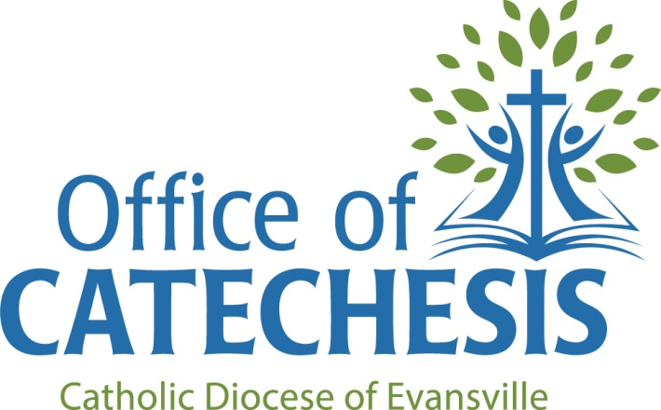

Recommended Religious Education Textbooks
for Parishes in the Diocese of Evansville

Series | Publisher | Representative
Christ Our Life | Loyola | Kathy Olenik Henry  800-256-0589 x339  henry@loyolapress.com
Finding God | Loyola | Kathy Olenik Henry  800-256-0589 x339  henry@loyolapress.com
Alive in Christ | OSV | Alexy Fyfe  260-446-2983  afyfe@osv.com
Gospel Weeklies | Pflaum | Bob Temme  855-295-9055 (toll free)  btemme@pflaum.com
Be My Disciples | RCL/Benziger | Linda Beckwith  Direct: 513-368-5104  lbeckwith@rclbenziger.com
Blest Are We | RCL/Benziger | Linda Beckwith  Direct: 513-368-5104  lbeckwith@rclbenziger.com
We Believe | Sadlier | Steven Allspaw  917-242-8725  sallspaw@sadlier.com

