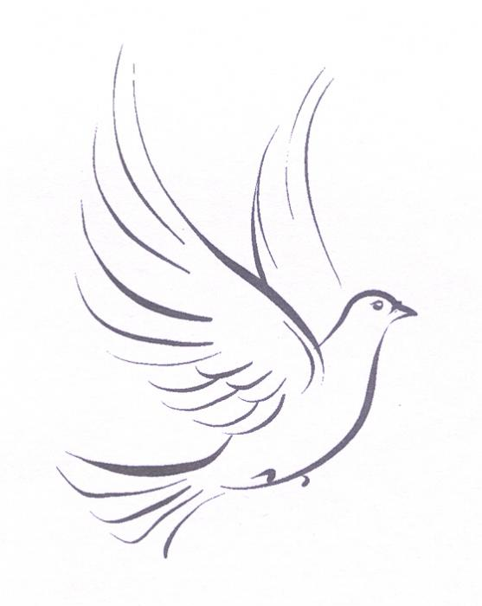

DIOCESE OF EVANSVILLE
SPIRITUAL DIRECTORS

Ann Collins
812-453-2630
New Harmony, Indiana

Sister Mary Claude Croteau, OSB
Monastery Immaculate Conception
802 E. Tenth St.
Ferdinand, IN 47532
812-367-1411
Sister Betty Drews, OSB
Monastery Immaculate Conception
802 E. Tenth St.
Ferdinand, IN 47532
812-367-1411
Sister Kathryn Huber, OSB
Monastery Immaculate Conception
802 E. Tenth St.
Ferdinand, IN 47532
812-367-1411
Sister Karen Joseph, OSB
Monastery Immaculate Conception
802 E. Tenth St.
Ferdinand, IN 47532
812 – 367-1411

Mary Ann Joyce
812- 867-7507
Evansville, IN 47720

Fr. Henry Kukendall
812-490-1000
Newburgh, Indiana 47630

Fr. Bernie Lutz
812- 632-0292
Newburgh, In 47630

Sr. Jane McConnell, OSF
812-479-0367
Evansville, Indiana 47714

Sr. Mary Mundy, SP
812-477-8923
Evansville, IN 47715

Theresa O’Bryan
812- 536-2841
Huntingburg, IN 47542

Patty Oser
812-631-2770
Jasper, IN 47546

Connie Schnapf
812-853-5164
Newburgh, IN 47630

Fr. Gene Schroeder
812-963-3273
Evansville, IN 47720

Sr. Jane Will, OSB
Monastery of the Immaculate Conception
802 E Tenth St.
Ferdinand IN 47532
812-367-1411

