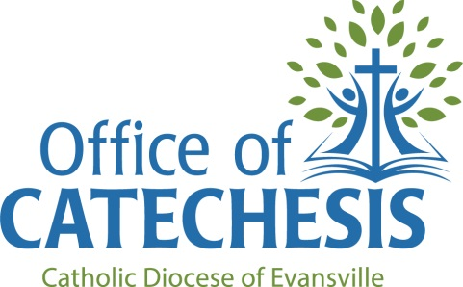

Spiritual Directors
in and around the Diocese of Evansville

Fr. Adrian Burke, OSB
St. Meinrad, IN aburke@saintmeinrad.edu
Ann Collins
812-453-2630
New Harmony, IN
Sister Betty Drews, OSB
Ferdinand, IN
812-631-3059

Dan Heckel
270-903-9364
Owensboro, KY

Sr. Susan Mary Hooks, OSB
Nashville, IN
812-639-1062
Sister Kathryn Huber, OSB
Ferdinand, IN
812-631-2959
Sister Karen Joseph, OSB
Ferdinand, IN
812-367-1411 ext. 2832

Mary Ann Joyce
812-867-7507
Evansville, IN

Fr. Gary Kaiser
Jasper, IN
gkaiser@evdio.org
812-482-4461 ext. 128

Sr. Joella Kidwell, OSB
Ferdinand, IN
812-367-1411 ext. 2835

Fr. Henry Kuykendall
812-490-1000
Newburgh, IN

Fr. Bernie Lutz
812- 632-0292
Newburgh, IN

Sr. Jane McConnell, OSF
812-479-0367
Evansville, IN

Sr. Patricia Ann McGuire, OSB
Evansville, IN
812-639-4113

Fr. Noel Mueller, OSB
St. Meinrad, IN nmueller@saintmeinrad.edu

Sr. Mary Mundy, SP
812-477-8923
Evansville, IN

Theresa O’Bryan
812- 536-2841
Huntingburg, IN

Patty Oser
812-631-2770
Jasper, IN

Fr. Jim Sauer
812-489-1013
Mount Vernon, IN

Connie Schnapf
812-853-5164
Newburgh, IN

Fr. Gene Schroeder
812-963-3273
Evansville, IN

Fr. Vincent Tobin, OSB
St. Meinrad, IN vtobin@saintmeinrad.edu

Gary Trogden
270-926-3585
Owensboro, KY

Fr. Jean Vogler
812-204-1426
Evansville, IN

Br. Francis Wagner, OSB
St. Meinrad, IN fwagner@saintmeinrad.edu

Sr. Mary Matthias Ward, OSU
Owensboro, KY
270-229-0200

Sr. Rose Wilderman, OSB
Ferdinand IN
812-367-1411 ext. 2615

Sr. Jane Will, OSB
Ferdinand IN
812-631-8976

