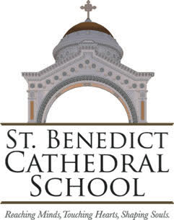

The Diocese of Evansville announces search for principal of
St. Benedict Cathedral School in Evansville, Indiana

The mission of St. Benedict Cathedral School is to form Christian disciples who proclaim the Catholic faith, achieve academic excellence, and serve others.
The school holds accreditation by Cognia, as well as the Indiana State Board of Education. St. Benedict Cathedral School is a member in good standing with the Indiana Non-Public Education Association and the National Catholic Education Association. The current enrollment is 315 students in PK – 8th grade.
Please send a cover letter and current resume to:
Michelle Priar, Superintendent of Schools
Diocese of Evansville, Catholic Schools Office
4200 North Kentucky Avenue, PO Box 4169
Evansville, IN 47724-0169

or

cso@evdio.org

Applications will be accepted until the position is filled.

School Website

Diocese of Evansville Catholic Schools Employment Opportunities
